Supplementary Information (SI)

1. Estimation of growth rate
Data from exponential growth observed after a process upset on day 146 were used to calculate the specific growth rate of the methanogens in this system.
Table S1. Dataset utilized to calculate growth rate of methanogens in the MBfR following process upset on day 146
Days Since Process Upset | CH₄ production (mL/min) | H₂ Consumption (mL/min) | CO₂ Consumption (mL/min) | % CH₄
0.66 | 0.04 | 0.14 | 0.04 | 11
4.71 | 0.05 | 0.22 | 0.05 | 37
5.77 | 0.12 | 0.49 | 0.12 | 66
6.71 | 0.25 | 1.01 | 0.25 | 72
7.65 | 0.32 | 1.26 | 0.32 | 72
8.75 | 0.21 | 0.84 | 0.21 | 75
11.74 | 0.23 | 0.93 | 0.23 | 80
12.83 | 0.33 | 1.30 | 0.33 | 90
13.72 | 0.27 | 1.09 | 0.27 | 91
14.76 | 0.26 | 1.05 | 0.26 | 94
15.72 | 0.29 | 1.16 | 0.29 | 94
18.73 | 0.27 | 1.09 | 0.27 | 96

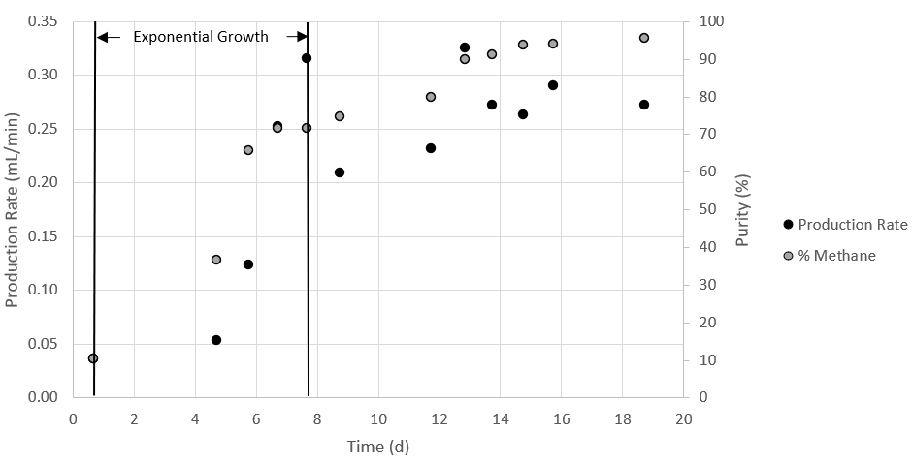
Fig. S1. Raw data plot of the MBfR methane production rate and quality in recovery period.
The exponential growth rate constant for the MBfR was calculated following the equation:
$$\begin{aligned}µ=\frac{\ln{N_{t}-\ln{N_{o}}}}{t} \#\left(S1\right)\end{aligned}$$
Where:
µ = exponential growth rate constant (/d),
N_{t} = methane production rate (mL/min) or quality (%) at the end of the exponential growth phase
N_{o} = methane production rate (mL/min) or quality (%) at the end of the exponential growth phase, and
t = time (days)
Based on the shape of the curves in Figure S1, t_{o} = 0.66 days and t = 7.65 days were selected. Corresponding CH₄ quality and production rates are listed in Table S2.
Table S2. Values for exponential growth rate estimation of the lab-scale MBfR methanogens based on product gas quality and methane production rate.
Exponential growth phase | Day | Based on CH₄:
 |  | Quality (%) | Production rate (mL/min)
Start | 0.66 | 11 | 0.036
End | 7.65 | 72 | 0.315
Growth Rate (/d) | µ | 0.27 | 0.31
Doubling Time (d) | T_{d} | 2.53 | 2.23

Based on the data in Table S2, the growth rate of the methanogens in the lab-scale MBfR ranges 0.27-0.31/d. The theoretical feed rate increase capacity of the lab-scale MBfR, in terms of H₂, was then calculated by combining the exponential growth and decay equation as follows:
$$\begin{aligned}Q_{t}= Q_{o}e^{\left(µ+k\right)t} \#\left(S2\right)\end{aligned}$$
Using:
Q_{t} = H₂ feed rate at time t (mL/min)
Q_{o} = initial H₂ feed rate (mL/min)
µ = exponential growth rate constant for the lab-scale MBfR methanogens (µ = 0.27/d)
k = exponential decay constant for hydrogenotrophic methanogens (k = –0.034/d),(Hao et al., 2012) and
t = time (days)
- Substrate Conversion Efficiency
Substrate conversion efficiencies represent the fraction of fed substrate that was transformed to CH₄. To exclude cell synthesis, substrate conversion efficiencies were based on CH₄ production according to the equations below:
$$\begin{aligned}H_{2} conversion efficiency \left(\%\right)=100*\frac{4C_{{CH}_{4}}Q_{PG}}{Q_{H_{2}}} \#(S3)\end{aligned}$$
$$\begin{aligned}{CO}_{2} conversion efficiency \left(\%\right)=100*\frac{C_{{CH}_{4}}Q_{PG}}{Q_{{CO}_{2}}} \#\left(S4\right)\end{aligned}$$
Reaction stoichiometry is according to the 4:1 ratio of H₂ to CH₄ in Equation 1.
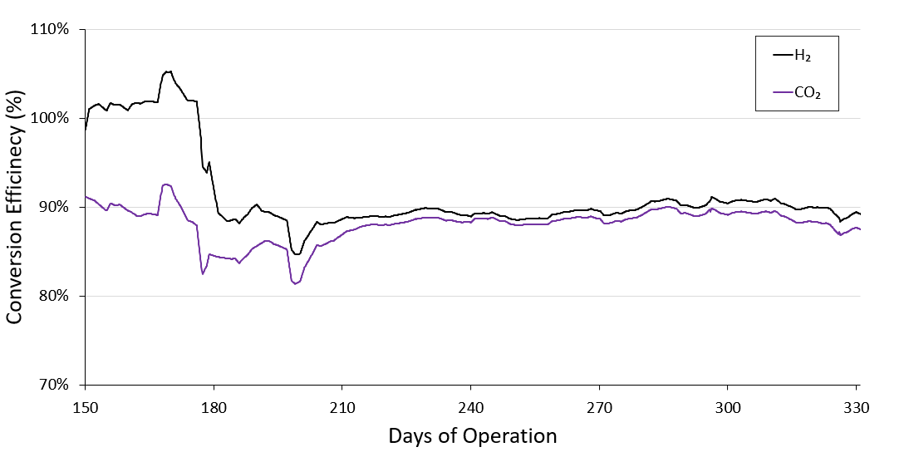
Fig. S2. Conversion efficiency Substrate conversions efficiencies are 30-day averages of the fraction of fed substrates converted to CH₄.

3. Transmembrane pressure
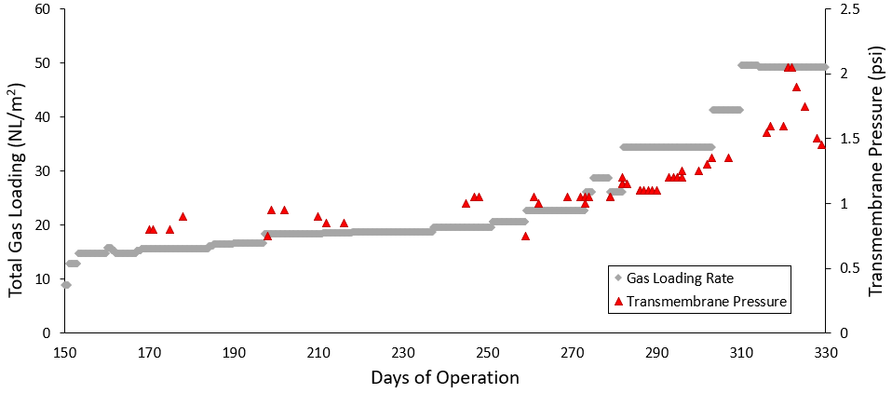
Fig. S3. Total substrate gas loading rates (H₂ and CO₂) normalized to membrane surface area and the observed backpressure exerted in the gas delivery line.

4. Estimation of fraction of VSS in biofilm
The fraction of VSS in biofilm in the reactor was estimated using the following equation:
$$\begin{aligned}Biofilm VSS fraction \left(\%\right)=100*\frac{{VSS}_{v}V_{v}}{{VSS}_{v}V_{v}+{VSS}_{e}V_{p}}\# \left(S5\right)\end{aligned}$$
Where:
VSS_{v} = VSS measured within the reactor (mg/L)
VSS_{e} = VSS measured just below the passive waste effluent (mg/L)
V_{v} = liquid volume of reactor (L)
V_{p} = liquid volume of system periphery (L)
This approach demonstrated that the reactor vessel, and biofilm, generally houses the majority of total system biomass as summarized in Fig. S2.
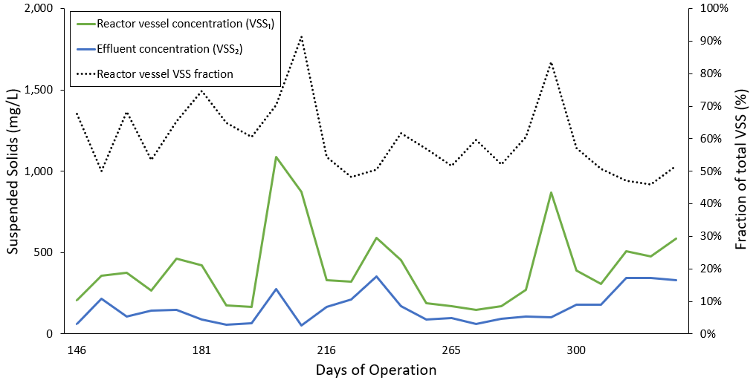
Fig. S4. Concentration of volatile suspended solids (VSS) measurements from the reactor vessel and from the reactor effluent. The estimated fraction of VSS housed in the reactor vessel as calculated using Equation SI 5 is also shown.

5. Metabolic Yield
Metabolic yield was calculated using NH₄-N based on pure cultures of hydrogenotrophic methanogens in serum vials (Rittmann and McCarty, 2020). Assuming, NH₄-N and CO₂ is the sum of CO₂ and HCO₃⁻ in the half reactions below (Table S3), the ideal feed ratio of H₂/CO₂ for hydrogenotrophic methanogenesis is 0.5/(0.115 + 0.016 + 0.004) = 3.703. Excluding HCO₃⁻ the ratio is 0.5/(0.115 + 0.016) = 3.816.
Accounting for cell synthesis with f_{s}º=0.08, the maximum H₂ conversion efficiency for CH₄ production is 0.92 mols H₂ converted/mol H₂ fed, or 92%.
Table S3. Half-reactions for cell synthesis and energy reaction for methanogenesis by hydrogenotrophic methanogens with H₂ as the electron donor and CO₂ as the electron acceptor.
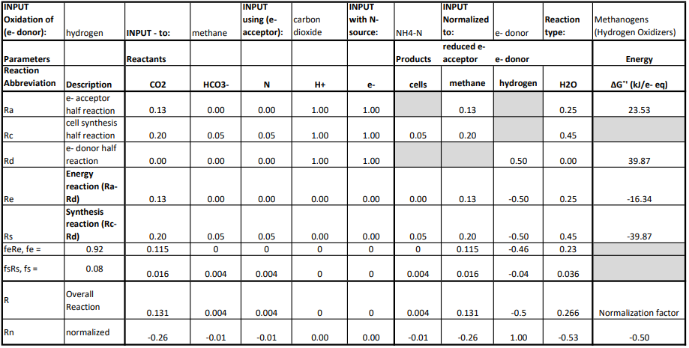

6. Soluble VFA and COD measurements
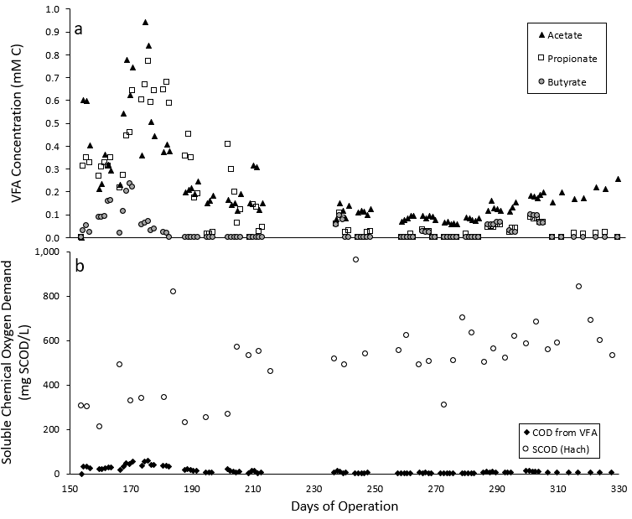
Fig. S5. Panel a) shows volatile fatty acid (VFA) concentrations measured in the reactor vessel throughout the experimental run. Panel b) shows the measured soluble chemical oxygen demand (COD) in the reactor vessel and the estimated contribution of measured VFAs to COD. It should be noted that average SCOD value for non-sterile influent media was 638 ± 173 mg COD/L.

7. Additional microbial community information
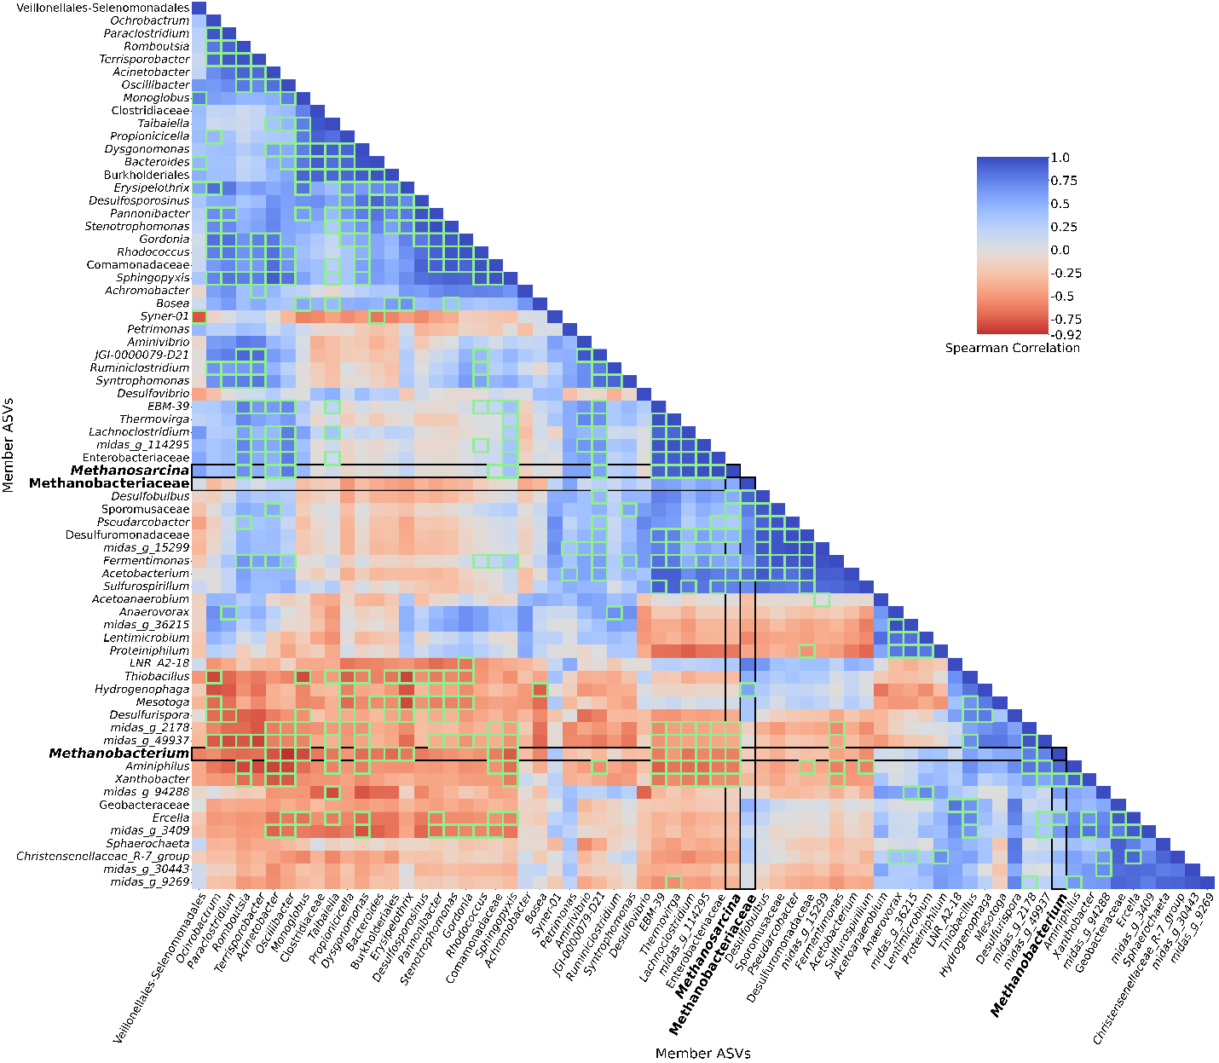
Fig. S6. A clustered heatmap of a correlational matrix of the relative abundances from all post-inoculum samples (Days 149-300). ASVs with the same MIDAS 5.3-classified Genus (or the last defined taxonomical level if the Genus is not specified) are summed within each sample. This approach examines ecology-level relationships and trends between members, instead of every possible ASV-level interaction. The methanogenic taxa are bolded and boxed to facilitate identifying the flanking community members that are most associated. The correlations of relative abundances between the respective row and column members are Spearman rank correlation coefficients, where the diagonal is R=1 by definition. The heatmap ranges from blue at R=1, white at R=0, and red at R=-1. Bright green boxes denote statistically significant correlations (p < 0.05).

Table S4. Iterative IDs and their corresponding ASVs and taxonomic classifications assigned by Midas 5.3
Iterative ID | ASV | MiDAS Taxonomy
Methanobacterium.1 | 0fec351445f84bd482075ceda6123f46 | Archaea Euryarchaeota Methanobacteria Methanobacteriales Methanobacteriaceae Methanobacterium
Methanobacterium.2 | 7f78afb7e1d45cd528fe9cd909c93fb5 | Archaea Euryarchaeota Methanobacteria Methanobacteriales Methanobacteriaceae Methanobacterium
Methanobacteriaceae.1 | 63f37ee4b481fccdffca10160ed5b944 | Archaea Euryarchaeota Methanobacteria Methanobacteriales Methanobacteriaceae nan
Mesotoga.1 | d3cf08daefed96f494257ceff63a6cf8 | Bacteria Thermotogota Thermotogae Kosmotogales Kosmotogaceae Mesotoga
Lentimicrobium.1 | c55a8101fb6c187736f0af61f720cb92 | Bacteria Bacteroidota Bacteroidia Sphingobacteriales Lentimicrobiaceae Lentimicrobium
Aminivibrio.1 | 04869be25e3dc4d526ce3824d407aedf | Bacteria Synergistota Synergistia Synergistales Synergistaceae Aminivibrio
midas_g_94288.1 | 37a9f9625f201b6e61c29ac09ec54683 | Bacteria Firmicutes Clostridia Gracilibacteraceae Lutispora midas_g_94288
Desulfovibrio.1 | b3d8bf326297fb9b18ea4fef1ce8d4a6 | Bacteria Desulfobacterota Desulfovibrionia Desulfovibrionales Desulfovibrionaceae Desulfovibrio
Methanobacterium.3 | 09ee5eb3e6c726c7c8242f6e97453fc2 | Archaea Euryarchaeota Methanobacteria Methanobacteriales Methanobacteriaceae Methanobacterium
Petrimonas.1 | 83adaf3a09d08c93f2abea6a4c815592 | Bacteria Bacteroidota Bacteroidia Bacteroidales Dysgonomonadaceae Petrimonas
Burkholderiales.1 | b64cf0e9dea8cef6b9500b364c179b98 | Bacteria Proteobacteria Gammaproteobacteria Burkholderiales nan nan
midas_g_9269.1 | 93fadef301b62aa732e42bf1142b3afa | Bacteria Bacteroidota Bacteroidia Bacteroidales Paludibacteraceae midas_g_9269
Methanobacterium.5 | 19463e5fe824700110e4a4ec8afe0512 | Archaea Euryarchaeota Methanobacteria Methanobacteriales Methanobacteriaceae Methanobacterium
Proteiniphilum.1 | e6485d233ed2b8b9a2f3f50f0747b9d2 | Bacteria Bacteroidota Bacteroidia Bacteroidales Dysgonomonadaceae Proteiniphilum
midas_g_36215.1 | 5976a56adfe903f7348b5eb5689e3c55 | Bacteria Bacteroidota Bacteroidia Bacteroidales Rikenellaceae midas_g_36215
Methanobacterium.6 | 38b371de3be6ddef03bea94294e9830d | Archaea Euryarchaeota Methanobacteria Methanobacteriales Methanobacteriaceae Methanobacterium
Enterobacteriaceae.1 | c571cb007a7d9e2dfc56e8c0b4e24104 | Bacteria Proteobacteria Gammaproteobacteria Enterobacterales Enterobacteriaceae nan
EBM-39.1 | 25c54c57b4a4283237b33fdae82003c0 | Bacteria Synergistota Synergistia Synergistales Synergistaceae EBM-39
Dysgonomonas.1 | 4bea53b2aad77f2569a0182f6b84255e | Bacteria Bacteroidota Bacteroidia Bacteroidales Dysgonomonadaceae Dysgonomonas
Methanobacterium.78 | a353b92733af5260a57dd1a0ba3001e1 | Archaea Euryarchaeota Methanobacteria Methanobacteriales Methanobacteriaceae Methanobacterium
midas_g_25828.1 | d48429274cd09a4257ad8b24c009e8fd | Bacteria Bacteroidota Bacteroidia Bacteroidales Prolixibacteraceae midas_g_25828
Azoarcus.4 | cd05a4b1cda569ae366c6980823f4c72 | Bacteria Proteobacteria Gammaproteobacteria Burkholderiales Rhodocyclaceae Azoarcus
Desulfovibrio.3 | bb617d32673d5f60d6216a07ad7a42bc | Bacteria Desulfobacterota Desulfovibrionia Desulfovibrionales Desulfovibrionaceae Desulfovibrio
Desulfomicrobium.1 | e1382120e151d51cb3b3b6900845f1c8 | Bacteria Desulfobacterota Desulfovibrionia Desulfovibrionales Desulfomicrobiaceae Desulfomicrobium
Stappia.1 | 52708c2cfa926ba9b2f69878c97cee2c | Bacteria Proteobacteria Alphaproteobacteria Rhizobiales Stappiaceae Stappia
midas_g_1799.7 | 0b736ddea36ed16291fa058fe28061f8 | Bacteria Firmicutes Clostridia Proteinivoracales midas_f_1799 midas_g_1799
midas_g_7.1 | 04e715f54c06e9ccf25afba02b343b5c | Bacteria Firmicutes Dethiobacteria Dethiobacterales Dethiobacteraceae midas_g_7
Dethiobacteraceae.4 | 07e00e1bcc9d9a3c50591f721785e591 | Bacteria Firmicutes Dethiobacteria Dethiobacterales Dethiobacteraceae nan
Soehngenia.2 | cd1f95189b8375347f827f4a8b08dcf7 | Bacteria Firmicutes Clostridia Peptostreptococcales-Tissierellales Family_XI Soehngenia

8. Biofilm formation
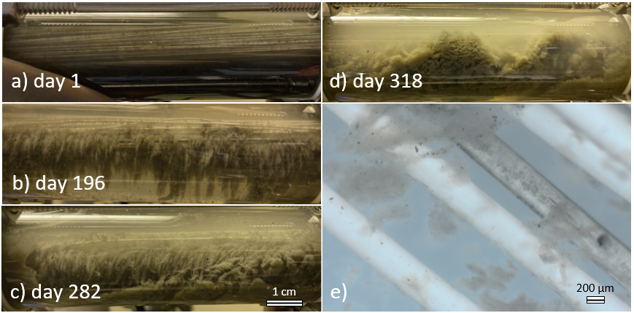
Fig. S7. Photos of biofilm development over the course of operation of the MBfR. Panels represent: a) suspended biomass after inoculation, b) stable biofilm, d) hybrid operation at higher substrate loading rates, e) dense biofilm and suspended growth, and e) stereoscope image of biofilm showing loose attachment.

9. Continuously monitored parameters

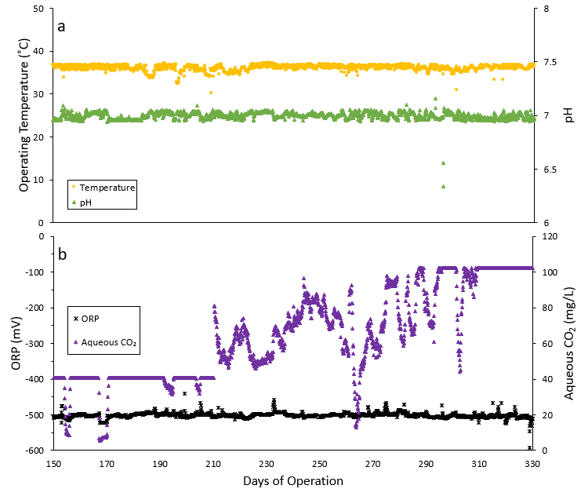
Fig. S8. Data from inline continuous sensing indicates overall process stability and control over the course of the experimental run. Panel a) represents pH and temperature measurements. Generally, temperature only decreased or increased during prolonged sampling events (i.e. sampling biofilm). Panel b) represents oxidation reduction potential, which remained in a range favorable for methanogenesis (-500 mV) except during prolonged sampling events. The aqueous CO₂ sensor was used to primarily serve as a qualitative, rather than quantitative, indicator of trends to inform real-time operational decisions.

